MORNING WORSHIP SERVICE
Oct 18, 2015

Opening Song “This Little Light of Mine”

Opening Prayer/Announcements

Worship Hymns “When the Morning Comes” 522
“I Need Thee Every Hour” 450
“Saved, Saved, Saved”
“We Have Come into His House” 361
“holy Ground” 224

Offering/Offertory

Special Music

Message Bro. David Atwood
Join us next week, Oct. 25 for our Annual High Attendance Sunday! Help us fill the Lord’s House with His praises.
The men are cooking breakfast, so come early for some great food and fellowship…..and bring a friend or 2.
Breakfast served from 8:00 am – 9:30 am
.
Invitation “I Am Resolved” 301

Closing Prayer

No Evening Service

Living Proof Live
March 4-5, 2016 (Fri & Sat)
Waco, TX: Extraco Event Center
Contact Patti Radford if you might be interested in attending

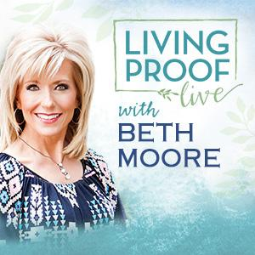
NURSERY – available for children age 0 to Kindergarten
Shirley Marecle

Hostesses for October Ushers for October
Diann Stutes, Evelyn Robinson, Sam McManus, Wesley McManus,
Hugo & Carolyne Breithaupt Joe Wilson, Bobby Stutes

Immediate Need Prayer List
Prayer & Request Information

(Please complete name & address information on reverse side)

I would like to speak with the Pastor.

I would like more information on this church.

I have Prayer Requests or Needs

Date:

Permission to Publicize:
Church Bulletin Yes No
Email Prayer Chain Yes No

Prayer Request:

Prayer For
Name
Address
Phone

Given By
Name
Address
Phone
Please Contact By

Card Phone Visit

Comments

Pray Bobby Coffey, he was in an ATV accident

Pray for Danny Sherman as he recovers from by-pass surgery

Pray for Ervin Griffith as he recovers from illness

K s b c

Keeping His Word through Sunday School, Bible Study and Church Attendance/Worship

Sunday School Bible Studies for October:

Oct 4th God’s Promise of Victory Romans 8:28-39 Oct 11th God’s Promise of A New Home Revelation 21:1-8
Oct 18th Develop Conviction Daniel 1:3-5,8-13,17-19
Oct 25th Pray Fervently Daniel 2:13-21,26-28a

9:45 a.m. each Sunday – A place for everyone

WE’D LOVE FOR YOU TO JOIN US!

